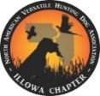
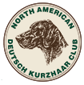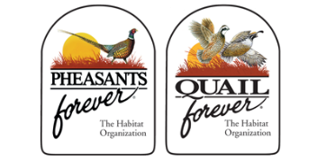 4th Annual Jerry Houtekier Memorial Youth Pheasant Hunt
Sponsored by ILLOWA NAVHDA / NADKC / Chapter 0317 PF/QF Application Form
Date: Saturday, October 19, 2024 9:00 am - 3:30 pm Henke-Benson Farm - 10447 55th Street - Wapello, IA 52653

The North American Versatile Hunting Dog Association (NAVHDA) is a legally recognized non-profit organization dedicated to fostering, improving, promoting and protecting the versatile hunting dog in North America. Underlying these aims is the desire to serve the interests of game conservation, the prevention of cruelty to animals, and good sportsmanship, by encouraging hunters to use dogs that are well-trained in work before and after the shot, on land and in the water.
The North American Deutsch Kurzhaar Club (NADKC) provides versatile hunting Deutsch Kurzhaars for the foot-hunter, developed through testing and breeding programs as set forth by the Deutsch Kurzhaar Verband (DKV) & Jagdgebrauchshundverband e.V. (JGHV)
What is the Youth Pheasant Hunt? The day will start with a brief review of hunting safety and rules followed by gun safety and trapshooting. Participants will rotate between sessions that include dog handling, wildlife identification, a field hunt and more. All guns, ammo, blaze orange and food will be provided. There is no cost for this program thanks to NAVHDA / NADKC / LC Pheasants & Quail Forever and generous donations from area sponsors. Each Youth will be gifted a membership to Pheasants Forever by the chapter.

The hunt: Multiple fields will be used to take the youth on a guided hunt. A mentor will always walk with the youth making sure they are safe. The hunt will be over a well-trained dog with a dog handler. Rooster pheasants will be liberated in the field prior to the hunt ensuring that the youth see pheasants.

Who is eligible to apply? Youth ages 10-15 who have successfully passed a hunter education course.

Application Process: We are only able to accommodate 18-21 youth for this program. All interested youth should fill out this application form. PLEASE PRINT CLEARLY.

Name: _________________________________________ | Grade: __________ Age:__________ DOB: _____________________
Address: _______________________________________ | City: ___________________ State: _________ Zip: _______________
Phone: ________________________________________ | Email: ___________________________________________________
Can we send you confirmation information via email?  no  yes

I have taken a hunter education class. Hunter Education #: ____________________ (on certificate) I plan to take a hunter education class. Date & Location: _________________________________________

Please mark all that apply:
- My father/mother is deployed with the military.
- My parents do not hunt
- I do not have anyone to take me hunting (including Uncles, Grandpas…)

Please write a brief sentence as to why you would like to attend the Youth Pheasant Hunt:

Please return this application by October 1, 2023 to:
ILLOWA NAVHDA Youth Hunt
6442 114th Ave., Wapello, IA 52653
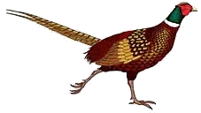
Questions Contact: Bobbi Benson at 309-337-7708 or spinone980@gmail.com
Check out www.illowanavhda.org for more info.

